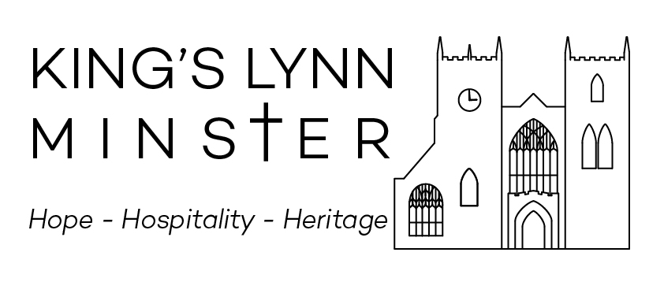

July 2023

Sunday 2 July (Trinity IV) no David no scotts
10am Parish Eucharist
Hymns 2, 230, 395, 249, 99
Organ Voluntary

5pm Choral Eucharist

Hymns 200, 230, 263, And can it be

Gradual Psalm 13 (Carter)

Setting St Margaret’s setting – Jordan

Communion Motet Ave verum – Byrd

Organ voluntary Tu es Petra – Mulet

Sunday 9 July (Sea Sunday)
10am Choral Eucharist at St Nicholas Chapel
Hymns 207, 64, 262, 292
Gradual Psalm 45 10-end
Setting Missa L’Hora Passa – Viadana
Motet Set me s as seal – Walton

5pm Healing service with hymns (tbc)
Organist

Sunday 16 July (Trinity VI) no david
10am Choral Eucharist
Hymns 146, 166, 156, 49
Gradual Psalm (No Psalm due to civic service)
Setting Darke in E
Motet Ave verum – Byrd

11:45am Festival Service
Organ music
Hymns As agreed – can’t remember them at the moment!
Responses Ayleward
Canticle Julbilate in B flat – Stanford
Anthem Make a Joyful Noise – A. Lloyd-Webber
National Anthem arr. Britten
Organ Voluntary
Organist Simon Kirk

July 2023

Sunday 16 July (Trinity VI) continued
5pm Said Evensong with hymns
Hymns 283(t.332), 211(t.113, omit v5&6), 7
Organist ?

Sunday 23 July (Trinity VII)
10am Parish Eucharist
Hymns 132, 372, 115, Sweet Sacrament (NEH 307), 346 (t.205)

Organ Voluntary

5pm Festival Evensong for Mary Magdalene

Hymns 188 (omit 6,7,8), 518, 422

Introit Ubi caritas – Duruflé

Responses Tunnard

Psalm 11 (Sinclair)

Canticles Sumsion in G

Anthem Beati quorum via – Stanford

Organ voluntary

Organist Simon Kirk

Sunday 30 July (Trinity VIII)
10pm Parish Eucharist
Hymns 289, 367, 170, 280, 343
Organ Voluntary

5pm Said Evensong with hymns

Hymns 469 (t.?), 176, 185
Organist

Choir on Holiday until Sunday 4 September 2022

