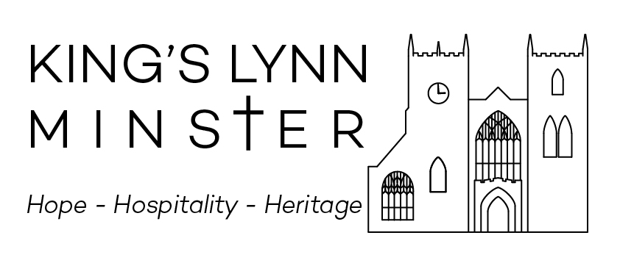Music for December 2023

Sunday 3 December (Advent Sunday)
Choir Practice: Friday 1st 7:30 and Sunday 3:45 (Scotts)
10am Parish Eucharist

Hymns 24, 25, 470, 164 (t.272), 28

Organ voluntary Chorale Prelude on Wachet auf, BWV645 – JS Bach

5pm Advent Carol Service
A service of readings and Music based around the Great ‘O’ Antiphons
(See website for details)

Sunday 10 December (St Nicholas)
Choir Practice: Friday 8th (No DO, RS, AS)

10am Sung Eucharist in St Nicholas’ Chapel
Hymns For all your Saints still active, 301,332 (v. 5-9),
Wonder worker
Psalm 96 v.1, 10-end

Setting Batten Short Service
Communion motet Hymn to St Nicholas (trad. arranged A. Richards)

Organ Voluntary Wir glauben all an einen Gott, BWV680 – JS Bach

5pm Said Evensong with hymns

Hymns 31, 405, 178???

Sunday 17 December (Advent III)

Choir Practice: Friday 15th 7:30 and Sunday 3:45 (Scotts)

10am Parish Eucharist
Hymns 32, 27, 142, 244, 180

Organ Voluntary Rhapsody on Helmsley – William Lloyd Webber

5pm Town Carol Service
A service of Nine Lessons and Carols
(See website for details)

Music for December 2023

Sunday 24 December (Advent IV)
Choir Practice: Sunday 24th 10:30? (No Scotts)

10am Parish Eucharist
Hymns 26, 31, 484, 360, 422
Organ Voluntary Toccata on Vom Himmel Hoch – Edmundson

11:30pm Midnight Mass (Choral Eucharist)
Hymns 46, 37/40, 326, motet, 35
Psalm 89 v.1-8

Setting Short Service – Batten
Communion motet tba
Organ Voluntary Final from Symphony nº 1 – Vierne

Monday 25 December (Christmas Day)
10am Parish Eucharist

Hymns 46, 37, 326, 42, 35

Organ voluntary Toccata from Symphonie nº 5 – CM Widor

No Evensong

(Choir on holiday until Sunday 14th January)

